Q6. Rail Fence Cipher Implementation with Performance Analysis
def print_matrix(matrix):
for row in matrix:
print(" ".join(ch if ch != '\n' else " " for ch in row))
def encrypt(text, key):
if key == 1:
return text
rail = [['\n' for _ in range(len(text))] for _ in range(key)]
row, col = 0, 0
direction_down = False
for ch in text:
if row == 0 or row == key - 1:
direction_down = not direction_down
rail[row][col] = ch
col += 1
if direction_down:
row += 1
else:
row -= 1
print("\nEncryption Rail Matrix:")
print_matrix(rail)
cipher = ""
for i in range(key):
for j in range(len(text)):
if rail[i][j] != '\n':
cipher += rail[i][j]
return cipher
def decrypt(cipher, key):
if key == 1:
return cipher
rail = [['\n' for _ in range(len(cipher))] for _ in range(key)]
direction_down = True
for i in range(len(cipher)):
rail[row][col] = '*'
col += 1
if row == 0:
direction_down = True
elif row == key - 1:
direction_down = False
if direction_down:
row += 1
else:
row -= 1
index = 0
for i in range(key):
for j in range(len(cipher)):
if rail[i][j] == '*' and index < len(cipher):
rail[i][j] = cipher[index]
index += 1
print("\nDecryption Rail Matrix:")
print_matrix(rail)
result = ""
row, col = 0, 0
direction_down = True
for i in range(len(cipher)):
result += rail[row][col]
col += 1

if row == 0:
direction_down = True
elif row == key - 1:
direction_down = False
if direction_down:
row += 1
else:
row -= 1
return result
text = input("Enter Plaintext: ")
key = int(input("Enter Number of Rails: "))
cipher = encrypt(text, key)
print("\nEncrypted Text:", cipher)
plain = decrypt(cipher, key)
print("\nDecrypted Text:", plain)

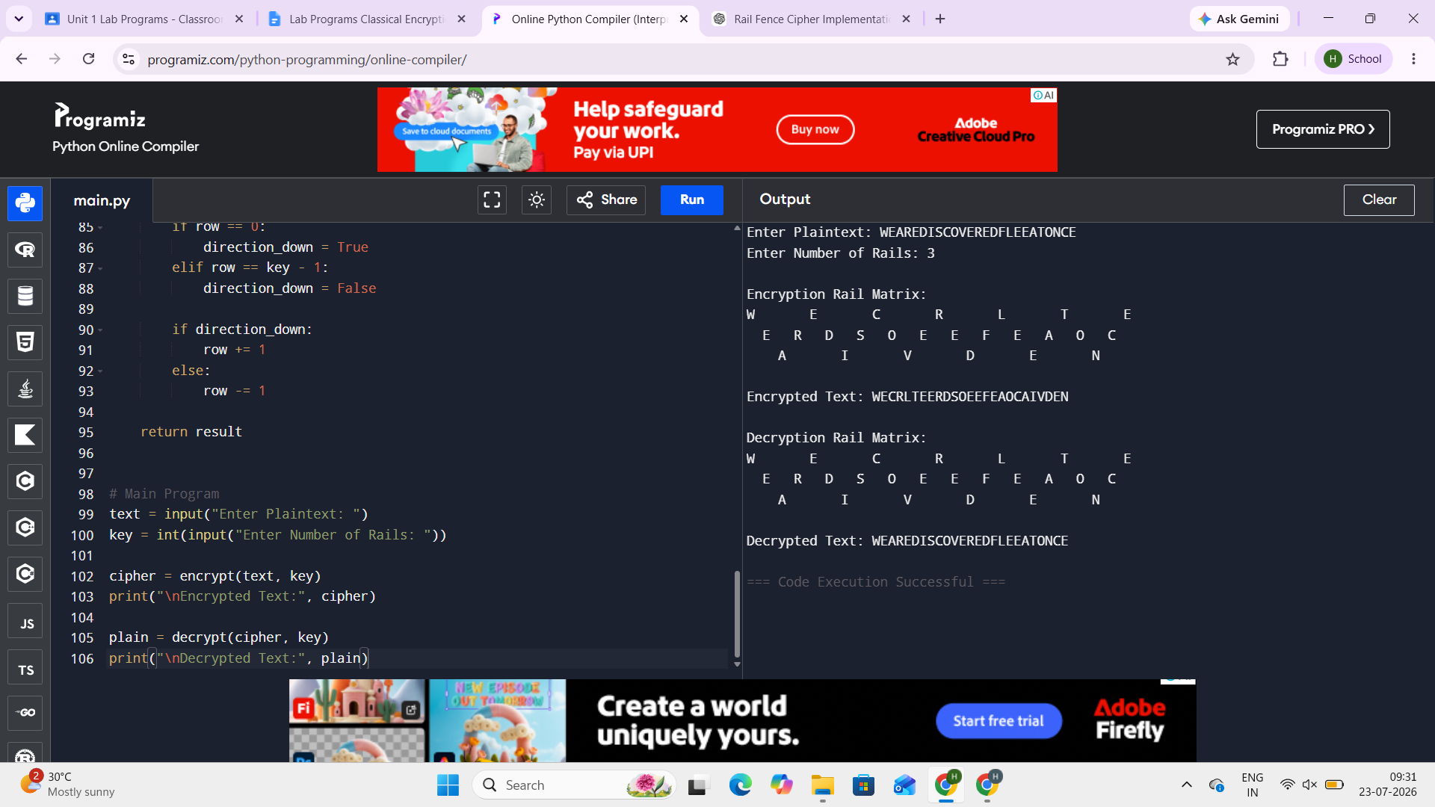
Q7.Simple Columnar Transposition with Padding Handling
import math
def print_matrix(matrix):
for row in matrix:
print(" ".join(row))
def encrypt(plaintext, cols, pad):
rows = math.ceil(len(plaintext) / cols)
padding = rows * cols - len(plaintext)
plaintext += pad * padding
matrix = []
index = 0
for i in range(rows):
row = []
for j in range(cols):
row.append(plaintext[index])
index += 1
matrix.append(row)
print("\nRow-wise Filled Matrix:")
print_matrix(matrix)
cipher = ""
for j in range(cols):
for i in range(rows):
cipher += matrix[i][j]
return cipher
def decrypt(ciphertext, cols, pad):
rows = len(ciphertext) // cols
matrix = [['' for _ in range(cols)] for _ in range(rows)]
index = 0
for j in range(cols):
for i in range(rows):
matrix[i][j] = ciphertext[index]
index += 1
print("\nMatrix During Decryption:")
print_matrix(matrix)
plaintext = ""
for i in range(rows):
for j in range(cols):
plaintext += matrix[i][j]
plaintext = plaintext.rstrip(pad)
return plaintext
text = input("Enter Plaintext: ")
cols = int(input("Enter Numeric Key Length (Columns): "))
pad = input("Enter Padding Character: ")
cipher = encrypt(text, cols, pad)
print("\nCiphertext:", cipher)
plain = decrypt(cipher, cols, pad)
print("\nDecrypted Text:", plain)
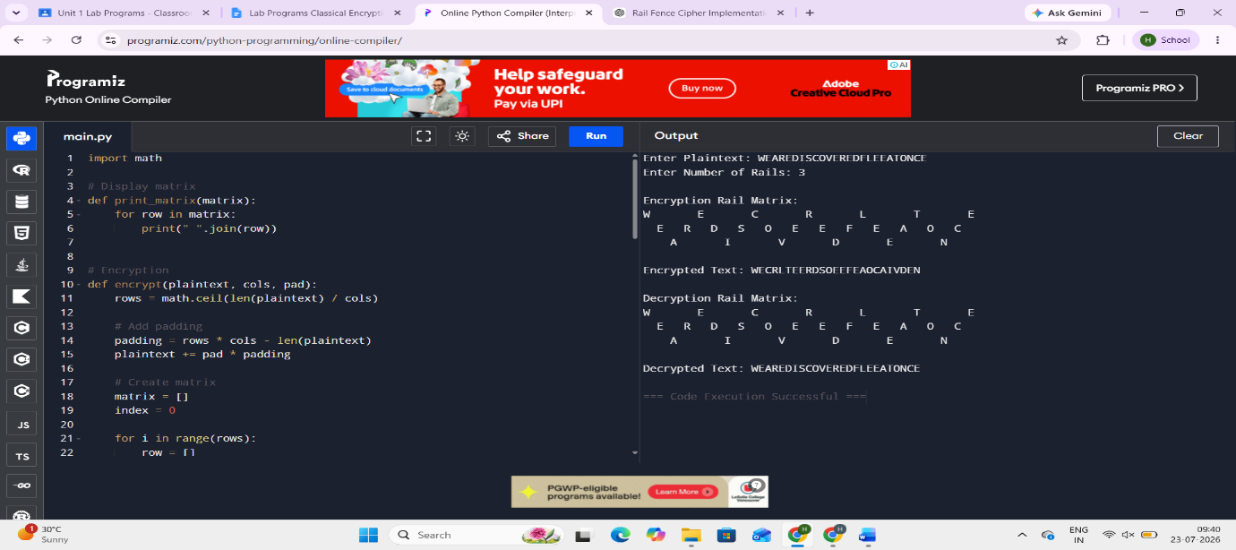
Q8.Keyed Columnar Transposition Cipher with Keyword Ranking
import math
def get_key_order(keyword):
indexed = list(enumerate(keyword))
sorted_key = sorted(indexed, key=lambda x: (x[1], x[0]))
order = [0] * len(keyword)
for rank, (index, _) in enumerate(sorted_key):
order[index] = rank + 1
return order
def print_matrix(matrix):
for row in matrix:
print(" ".join(row))
def encrypt(text, keyword, pad='X'):
cols = len(keyword)
rows = math.ceil(len(text) / cols)
text += pad * (rows * cols - len(text))
matrix = []
index = 0
for i in range(rows):
row = []
for j in range(cols):
row.append(text[index])
index += 1
matrix.append(row)
print("\nOriginal Matrix:")
print_matrix(matrix)
rank = get_key_order(keyword)
print("\nKeyword Ranking:")
for i in range(cols):
print(f"{keyword[i]} -> {rank[i]}")
sorted_cols = sorted(range(cols), key=lambda x: rank[x])
permuted = []
for row in matrix:
permuted.append([row[i] for i in sorted_cols])
print("\nPermuted Matrix:")
print_matrix(permuted)
cipher = ""
for col in sorted_cols:
for row in range(rows):
cipher += matrix[row][col]
return cipher
def decrypt(cipher, keyword, pad='X'):
cols = len(keyword)
rows = len(cipher) // cols
rank = get_key_order(keyword)
sorted_cols = sorted(range(cols), key=lambda x: rank[x])
matrix = [['' for _ in range(cols)] for _ in range(rows)]
index = 0
for col in sorted_cols:
for row in range(rows):
matrix[row][col] = cipher[index]
index += 1
print("\nDecryption Matrix:")
print_matrix(matrix)
text = ""
for row in matrix:
text += "".join(row)
return text.rstrip
plaintext = input("Enter Plaintext: ")
keyword = input("Enter Keyword: ").upper()
cipher = encrypt(plaintext.upper(), keyword)
print("\nEncrypted Text:", cipher)
plain = decrypt(cipher, keyword)
print("\nDecrypted Text:", plain)
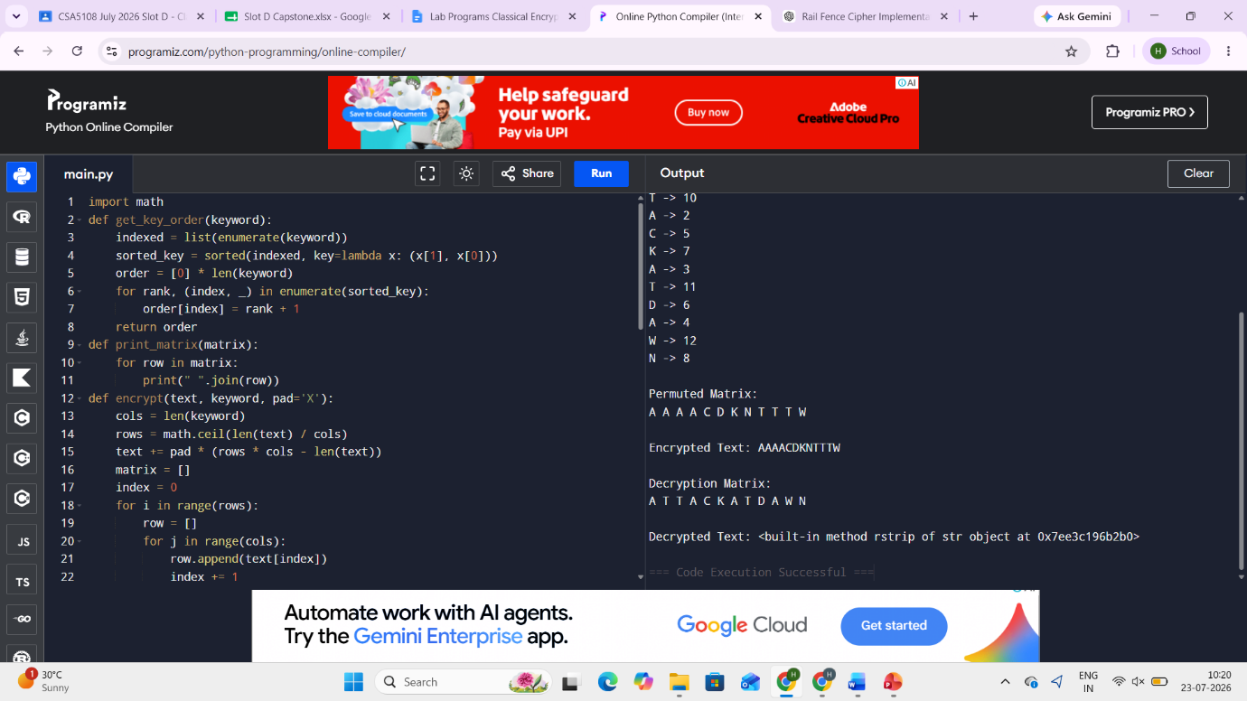
Q9.Double Transposition Cipher with Security Comparison
import math
import time
import random
import string
import matplotlib.pyplot as plt
def rankkey(k):
a=sorted([(c,i)for i,c in enumerate(k)])
r=[0]*len(k)
for n,(_,i) in enumerate(a):
r[i]=n
return r
def enc(t,k):
c=len(k)
r=math.ceil(len(t)/c)
t=t+"X"*(r*c-len(t))
m=[list(t[i*c:(i+1)*c])for i in range(r)]
o=rankkey(k)
s=sorted(range(c),key=lambda x:o[x])
x=""
for j in s:
for i in range(r):
x+=m[i][j]
return x
def dec(ct,k):
c=len(k)
r=len(ct)//c
m=[['']*c for _ in range(r)]
o=rankkey(k)
s=sorted(range(c),key=lambda x:o[x])
p=0
for j in s:
for i in range(r):
m[i][j]=ct[p]
p+=1
t=""
for i in range(r):
t+="".join(m[i])
return t.rstrip("X")

def single(t,k):
return enc(t,k)
def double(t,k1,k2):
return enc(enc(t,k1),k2)
def doubledec(t,k1,k2):
return dec(dec(t,k2),k1)
def randomtext(n):
return ''.join(random.choice(string.ascii_uppercase)for _ in range(n))
p=input("Enter Plaintext: ").upper()
k1=input("Enter First Key: ").upper()
k2=input("Enter Second Key: ").upper()
c1=enc(p,k1)
print("First Transposition:",c1)
c2=enc(c1,k2)
print("Second Transposition:",c2)
d1=dec(c2,k2)
print("After First Decryption:",d1)
d2=dec(d1,k1)
print("Original Plaintext:",d2)
sizes=[100,500,1000]
st=[]
dt=[]
for n in sizes:
txt=randomtext(n)

a=time.perf_counter()
single(txt,k1)
st.append(time.perf_counter()-a)
b=time.perf_counter()
double(txt,k1,k2)
dt.append(time.perf_counter()-b)
plt.plot(sizes,st,marker='o',label="Single")
plt.plot(sizes,dt,marker='s',label="Double")
plt.xlabel("Input Size")
plt.ylabel("Execution Time")
plt.title("Single vs Double Transposition")
plt.legend()
plt.grid()
plt.show()
Q10. Cryptanalysis Tool for Transposition Cipher
from itertools import permutations
import math
freq="ETAOINSHRDLCUMWFGYPBVKJXQZ"
def score(t):
t=t.upper()
s=0
for i,c in enumerate(freq):
s+=t.count(c)*(26-i)
words=["THE","AND","ING","ION","ED","ER","TO","OF","IN","IS"]
for w in words:
s+=t.count(w)*100
return s

def decrypt(c,key):
cols=len(key)
rows=len(c)//cols
m=[['']*cols for _ in range(rows)]
p=0
for col in key:
for row in range(rows):
m[row][col]=c[p]
p+=1
t=""
for r in m:
t+="".join(r)
return t.rstrip("X")
cipher=input("Enter Ciphertext: ").upper()
result=[]
for k in range(2,9):
if len(cipher)%k!=0:
continue
for p in permutations(range(k)):
try:
text=decrypt(cipher,p)
result.append((score(text),k,p,text))
except:
pass
result.sort(reverse=True)
print("\nTop 5 Probable Plaintexts\n")
for i in range(min(5,len(result))):
s,k,p,t=result[i]
print("Rank",i+1)
print("Key Length:",k)
print("Permutation:",p)
print("Plaintext:",t)
print("Score:",s)
print()
